NOTE: I'm not using a software requirement specification for this... the requirement is simply to produce the most accurate mathematical expression segmentation technique and then to evaluate as objectively as possible.

1. INTRODUCTION
1.1 Purpose

The goal of this project is to enhance the quality of document layout analysis and OCR for printed (non-handwritten) technical/scientific public domain documents which may contain displayed/inline equations, matrices, illustrations, graphs, etc. Automated processing of such documents requires both physical and logical layout analysis techniques to be employed in order to segment and then classify zones of interest for correct processing. After physical layout analysis is carried out, regions corresponding to illustrations, plain text, musical notation, and mathematical formulas all must be classified so that they can be processed correctly. The application of this project is in automated processing of digitized public domain text books, articles, dissertations, etc (or non public domain documents with author/publisher consent and due legal permission). Automated document processing has seen widespread use in industrial settings (i.e. automated processing of bank notes or postage envelopes) as well as for Assistive Technology in aiding the blind and/or visually impaired in their accessibility to information. More controversially, document layout analysis and OCR has found use in the “Google Books Initiative” whose founders have envisioned a veritable online “Library of Alexandria” from which all of the world's knowledge could instantly be acquired from anywhere.
The purpose of this work is thus to develop and evaluate an equation detection and segmentation module to obtain favorable accuracy on a wide range of pages of printed public domain text, compare this equation detector’s accuracy to that of a default implementation provided within an existing layout analysis software, Tesseract [refer to tesseract], and to evaluate classifier performance under a wide variety of inputs.

1.2 Problem Statement and Project Scope
Currently, the commercial OCR system best suitable in handling scientific documents is Masakazu Suzuki's “Infty Reader” which can accurately recognize a wide variety of complex mathematical equations as well as matrices, assuming that they are first properly isolated from other, non-math, regions of text. While some of the system's shortcomings can be attributed to the merging or breaking of characters during image scanning, most of the system's errors can be attributed to the improper isolation of the math regions from non-math regions. The system isolates regions of interest based solely upon analysis of the output of a commercial OCR system, Abby Fine Reader. Regions which appear to be “junk output” are deemed as candidates for math recognition. Infty Reader sidesteps the problem of physical and logical layout analysis, relying solely upon whatever physical and logical layout analysis is performed by the proprietary Abby Fine Reader system utilized. The Infty Reader system's degree of document understanding prior to recognition, therefore, is entirely at the mercy of false positive recognitions and/or layout analysis errors made by Abby Fine Reader, which, in and of itself, was not even designed with the layout analysis of scientific/mathematical documents in mind.
Meanwhile, the “Google Books Initiative” project has spurred a great amount of interest in the automated processing of a wide variety of documents ranging from ancient texts, magazines, articles, to scientific/mathematical textbooks, dissertations, etc in over fifty languages. An experimental equation detector, for instance, was implemented as part of Google’s 2011 release of their open source OCR engine, Tesseract. Upon performing a preliminary evaluation of the equation detector on several pages of a public domain calculus text book (Advanced Calculus by Edwin Bidwell circa 1911), it was found that fewer than a fourth of the equation zones were fully segmented (refer to section where this evaluation is carried out). Of all of these fully segmented equation zones, none of them were without at least some false positive pixels and/or under/over-segmentations.
The primary goal of this project is to design, implement, and evaluate a system which can accurately detect and segment regions of text which correspond to mathematical equations and/or expressions. Since a significant problem observed in the existing literature is a lack of objective performance comparison among equation detectors, this work is tested primarily on public domain documents, with the evaluation software provided freely for academic/industrial use. While the general layout analysis framework of Tesseract will be utilized for this work, a new equation detector implementation will override Tesseract’s default one. The performance of Tesseract’s document layout analysis framework will be evaluated both under the default equation detector and the newly implemented one, the results compared, and experiments carried out on a variety of text formats in order to gain insight into how best to increase accuracy over a wide variety of documents while avoiding the problems of overtraining to the largest extent possible.

1.3 Overview
TODO: Provide an overview of this document and its organization. Will do this after done writing everything up REMEMBER THAT THIS WILL BE INCORPORATED INTO THE THESIS METHOD SECTION SO LAY OUT EVERYTHIGN WITH THAT IN MIND...
1.4 Definitions and Acronyms

mathematical expression detection and segmentation (MEDS) module

Put in whatever terminology from tesseract datastructures that i use...
physical segmentation
logical segmentation
other terms.... IMPORTANT: EXPLAIN WHAT A COLUMN PARTITION IS

2. SYSTEM OVERVIEW
Give a general description of the functionality, context and design of your project. Provide any
background information if necessary.

The software to be described herein is designed such that it may be utilized as a modular component working in coordination with other components to produce a full-fledged document layout analysis system. While the document layout analysis system, as a whole, is geared toward the proper segmentation and detection of all zones in an arbitrary printed document image (i.e. normal text, image, halftones, mathematical expressions, musical notation, logos, chemical equations, etc.), the subsystem to be described herein is geared toward only the proper detection and segmentation of mathematical expression regions. This subsystem is to be integrated with an existing layout analysis system, Tesseract [reference], and its results compared to those of a default implementation supplied with the software. The subsystem is then evaluated on a ground truth data set which includes 105 images all taken from public domain texts. Both the groundtruth generation procedure as well as the evaluation method will be herein described. The evaluation method objectively gauges performance by calculating true positive rate, precision, accuracy, false positive rate, false discovery rate, specificity, and negative predictive value all down to pixel-level [refer to shafait]. Both the dataset and evaluation tools are made freely open to the public in hopes that they may be made useful for the objective comparison of the subsystem's performance to any future or existing techniques.

3. SYSTEM ARCHITECTURE
This system consists of three primary components: the ground truth generation module, mathematical expression detection and segmentation (MEDS) module, and the evaluation module. Together, these three modules effectively comprise a test-driven development environment wherein MEDS modules may quickly be interchanged and evaluated against one another for objective performance comparison. All MEDS modules which can be evaluated by this system are fully integrated with Tesseract's document layout analysis software [refer to the hybrid article], and are instantiated by overriding Tesseract's BaseEquationDetect class [refer to the source file]. Tesseract utilizes a hybrid physical layout analysis approach to locate initial column partition candidates on the page which are then corrected through further type-specific document layout analysis techniques (i.e. segmentation algorithms for table, music, math, etc.). While Tesseract provides a default MEDS module, a preliminary evaluation of the module's accuracy [refer to section with specifics] has shown that there is significant room for improvement. Figures [???] and [diagram_fig] illustrate how the groundtruth generation, MEDS, and evaluation modules collaborate in order to foster a test-driven development environment for the enhancement of MEDS accuracy.
The system is first fed a PDF or document image from which the groundtruth is manually generated. The groundtruth will contain the bounding box coordinates for all displayed and embedded math expressions (and may also contain the coordinates of all displayed expression labels) (refer to section for specifics on this procedure). Both the input document image and the groundtruth are fed into the evaluation module which subsequently triggers Tesseract's document layout analysis software. The MEDS module to be evaluated is embedded in Tesseract's layout analysis software such that it is called after initial column partition estimates have been made through Tesseract's hybrid physical segmentation technique [refer to hybrid paper again]. Either Tesseract's default MEDS module can be evaluated or any new MEDS module may override Tesseract's default one so that it can be evaluated. Once the layout analysis software is finished being run on the document image (or multiple images if desired), the results of the MEDS module are evaluated against the groundtruth to obtain various evaluation metrics (refer to section where details are discussed). The resulting metrics for different MEDS modules evaluated on the same input data may then be objectively compared.

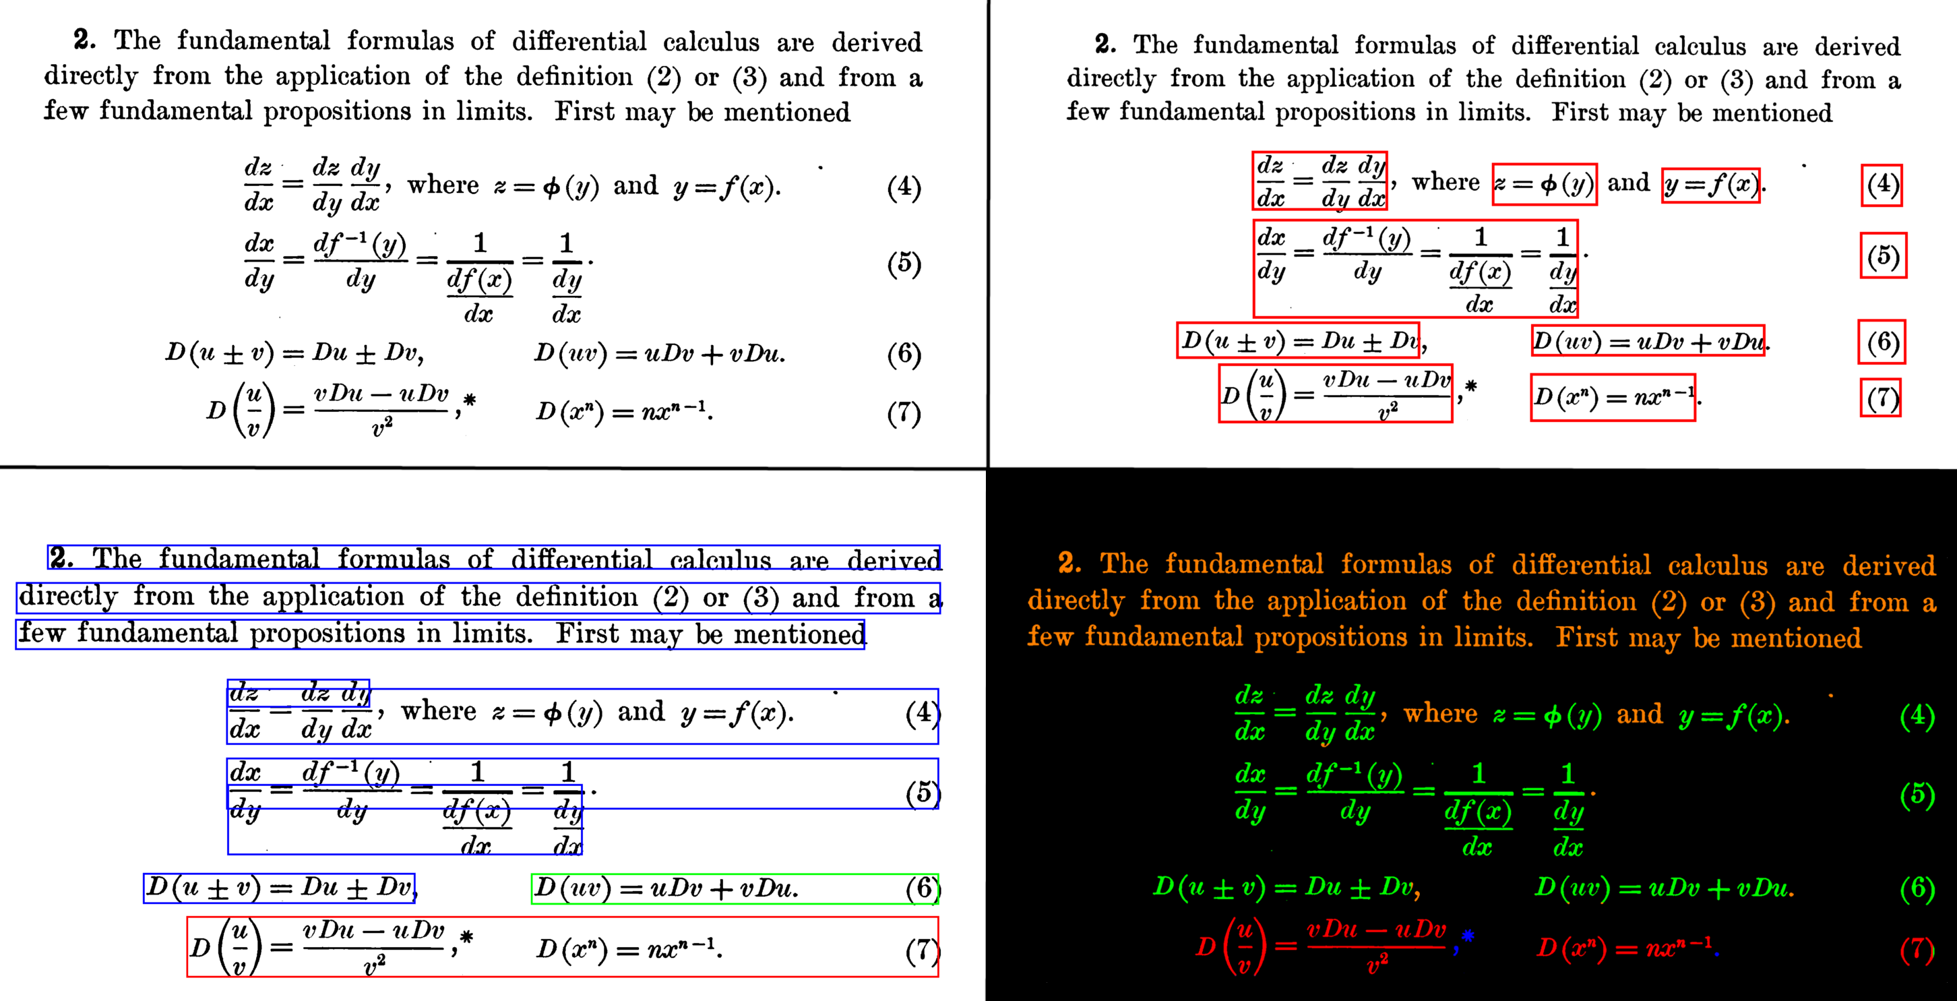Illustration 1: (Top-left) Input image segment. (Top-right) Manually generated groundtruth for input. Segments outlined with red rectangles are individual displayed expressions. (Bottom-left) Output of Tesseract's default MEDS module. Segments outlined with red rectangles are individual displayed expressions, segments outlined with green rectangles are individual embedded expressions, and segments outlined with blue rectangles are normal text. (Bottom-right) Pixel-accurate evaluation results for displayed expressions found in Tesseract's default module after comparing it to the groundtruth. False negative pixels are colored green, false positive pixels are colored blue, true positive pixels are colored red, and true negatives are orange. All background pixels are colored black.

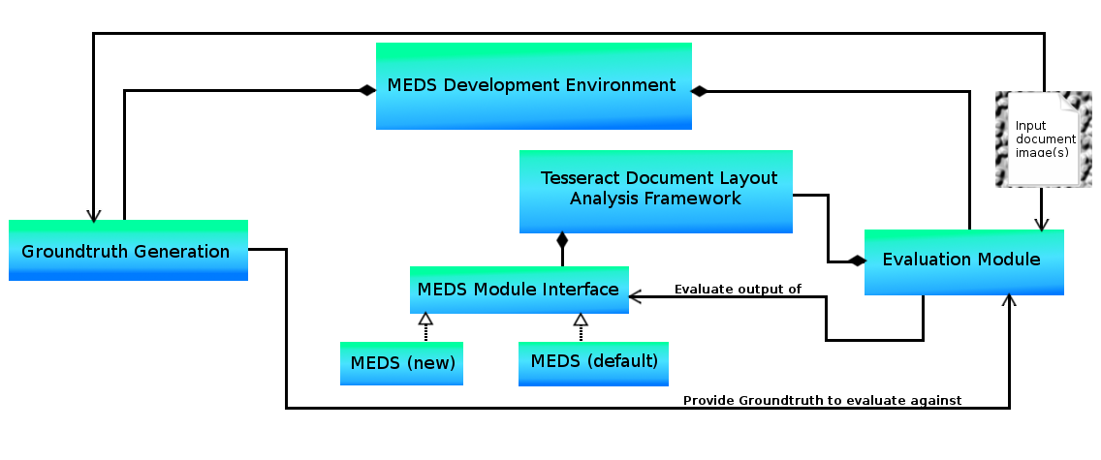Illustration 2: High-level UML-based overview of system architecture

4. DATA DESIGN TODO: Decide whether or not I really need this part... If I do it will have separate sections for the groundtruth generation, evaluation, and layout analysis module (for groundtruth generation show screenshot of user interface.. maybe just move that to teh component design section?????)... Do the next part first, then come back to this and see what can be done if anything is even necessary....
4.1 Data Description
Explain how the information domain of your system is transformed into data structures.
Describe how the major data or system entities are stored, processed and organized. List any
databases or data storage items.

Groundtruth Generation

Evaluation Module

MEDS Module

4.2 Data Dictionary ((???? This section may also be unnecessary...)
Alphabetically list the system entities or major data along with their types and descriptions. If
you provided a functional description in Section 3.2, list all the functions and function
parameters. If you provided an OO description, list the objects and its attributes, methods and
method parameters.

5. COMPONENT DESIGN This will go into greater detail for all of them.. do this one first... and most importantly.. do the MEDS module design first (all the others we've already implemented prior to designing anyway....)

In this section, we take a closer look at what each component does in a more systematic way. If
you gave a functional description in section 3.2, provide a summary of your algorithm for each
function listed in 3.2 in procedural description language (PDL) or pseudocode. If you gave an
OO description, summarize each object member function for all the objects listed in 3.2 in PDL
or pseudocode. Describe any local data when necessary.

Groundtruth Generation (TODO: work on this ONLY after MEDS module design is done!!!!!!)
TODO: Complete this.. Include screen shots of the GUI. Discuss the rules I set out, etc.....

Evaluation Module((TODO: work on this ONLY after MEDS module design is done!!!!!!)
TODO: Detailed description of how I implemented this.. maybe include UML, sequence diagrams etc???

MEDS Module

--- Design all the subcomponents etc. Might be a good idea to do another UML diagram for this module since there will be a lot of funcitonality required. There may be subcomponents that I will want to be pluggable within this module so I can try different things. The classifier is definitely an example of this... where else do I need a pluggable architecture???

Should I start with detecting the displayed expressions then do the embedded or the other way around?? These are the questions I need to start asking as I start my top-down design of this module.

Then from there get into the features, classifiers, etc...... You will probably want to try different classifiers for each respective task. Then merging or getting rid of regions will likely be based upon various heuristics. A lot of it will depend upon the nature of the colpartitions provided. A review of what tesseract is doint will be helpful..

